
FACULTY OF TECHNOLOGY AND ENGINEERING
DEVANG PATEL INSTITUTE OF ADVANCE TECHNOLOGY
AND RESEARCH

DEPARTMENT OF COMPUTER ENGINEERING

A.Y 2026 – 27 Semester – 3

LAB MANUAL

CSUC201 Fundamentals of Data Structures and Algorithms

Practical 9: Graph Traversal: Depth-First Search and
Breadth-First Search

Practical Aim : To implement depth-first and breadth-first traversal on a graph and develop the ability to reason
about how the order of exploration changes depending on the traversal strategy used.

Problem 1 : A disaster relief team needs to inspect all buildings in a city after an earthquake. The city is
mapped as a network where buildings are connected by roads. One team starts at a building
and goes as deep into each road as possible before backtracking, while a second team spreads
out level by level — first checking all buildings directly connected to the start, then all buildings
two roads away, and so on. Given the city map as a graph and a starting building, implement
both exploration strategies and print the order in which buildings are visited by each team.
Describe how the order of buildings visited differs between the two strategies on the same
graph. What data structure does each strategy rely on to decide which building to visit next, and
how does that structure cause the difference in order?

For Code: https://github.com/DivyaParadiya/FDSA_A_SHP

Output:
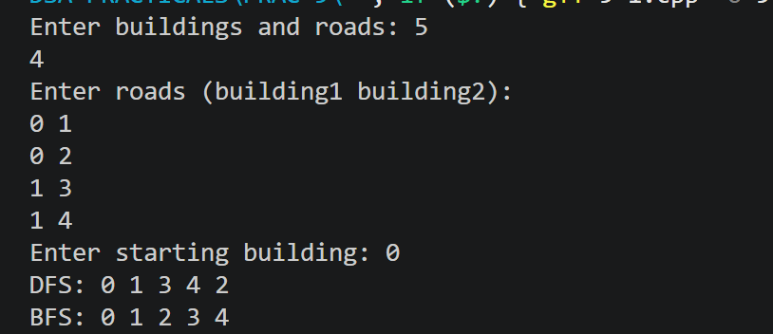

Outcome/Conclusion: Students will be able to implement DFS and BFS on a graph, explain how the underlying data
structure used by each strategy determines the order of traversal, and apply graph traversal
logic to detect structural properties such as cycles in an undirected graph.

Key Questions / Analysis / Interpretation to be Evaluated During/After Implementation

1.
Question: Inserting at a position beyond the current length of the list is an invalid operation. Should your solution silently insert at the end, report an error, or do something else entirely? Justify your choice and explain what assumption about the caller your choice makes.
Answer:
The solution should report an error if the insertion position is beyond the current length of the list. Silently inserting at the end may produce an unexpected result. Reporting an error makes the operation clear and maintains the correctness of the list. This choice assumes that the caller provides a valid position and expects the program to reject invalid positions rather than automatically correct them.

2.
Question: If the node to be deleted is the only node in the list, how many pointers need to change and what must they be set to? How is this case structurally different from deleting a node in the middle?
Answer:
If the node to be deleted is the only node in the list, both the head and tail pointers must be set to NULL. The node is then deleted from memory. This is different from deleting a middle node, where the previous node's next pointer is updated to point to the next node, while the head and tail generally remain unchanged.

